Assignment Kit for
Final Report

Personal Software Process for Engineers: Part II

The Software Engineering Institute (SEI)
is a federally funded research and development center
sponsored by the U.S. Department of Defense and
operated by Carnegie Mellon University.

This material is approved for public release.
Distribution limited by the Software Engineering Institute to attendees.

Personal Software Process for Engineers: Part II
Assignment Kit for the PSP Final Report
Overview

Overview | This assignment kit will cover the following topics
 | Section | See Page
 | Prerequisites | 2
 | Final report objectives | 2
 | Final report requirements | 3
 | Guidelines and evaluation criteria | 5
 | Report analysis questions | 6
 | Example analysis | 8
 | Report templates | 9

Prerequisites | Prerequisites  • Complete all PSP programs  • Complete all previous report assignments  • Read Chapters 13 and 14

Final report objectives | The objectives for this assignment are for you to  - produce a report on what you have learned from this course  - understand your current software development performance and your highest-priority areas for improvement  - understand how and why your performance changed between the interim report and the final program  - gain experience in establishing measurable goals, and defining corresponding improvement actions  - learn to update a personal process

Final report requirements

Final report requirements | Update the process that you used for the interim report.  Use this process to  - plan the final report task  - analyze your process data  - produce the report  - complete the postmortem  Submit the report, the process, and the process data.
Continued on next page
Final report requirements, Continued

Minimum analyses for the final report | At a minimum, you must  • analyze your size-estimating accuracy and determine the degree to which your estimates were within the 70% statistical prediction intervals. Also show how your size-estimating accuracy has evolved during the assignments.  • analyze your time-estimating accuracy and determine the degree to which your estimates were within the 70% statistical prediction intervals. Also show how your time-estimating accuracy has evolved during the assignments.  • analyze the types of defects that you injected in design and in coding. Include a Pareto analysis of these defect types.  • analyze your trends for defects per size unit (e.g., KLOC) found in design review, code review, compile, and test  • analyze your trend for total defects per size unit  • analyze your defect-removal rates for design reviews, code reviews, compile, and test, and your defect-removal leverage for design reviews, code reviews, and compile versus unit test. In those cases where you had no test defects, use the average unit test defect-removal rate for the programs developed to date.  • analyze yield versus size reviewed per hour in your code reviews  • analyze design-review yield versus size reviewed per hour  • analyze yield versus the A/FR for programs 5 through 8  • describe your highest-priority areas for personal process improvement and why. Be sure to summarize your current performance, desired future performance, and improvement goals. Describe how you intend to meet these goals.

Guidelines and evaluation criteria

General guidelines | Print the charts from your student workbook that cover the minimum analyses.  Analyze your data. There are study questions (see next page) that provide an example of how you might analyze your data for specific areas. Be sure to include any additional charts that you use in your analysis in your report.  Focus on analyzing your data to  • identify where you need to improve  • establish challenging improvement goals  • understand how to change your personal process to meet those goals  Write up a brief report describing your findings and conclusions.  Keep your report simple and short.  Do not hesitate to build on the PSP materials.

Evaluation criteria | Your process design must include a  • planning phase  • development phase  • postmortem phase  You must submit  • your process script  • the planning form you created and used  • other forms or logs you used  • your final report  Your report must include  • all of the tables and charts required, plus any other charts or data that support your analysis  • your written analysis and conclusions  • quantitative, measurable improvement goals, and specific actions that you plan to take to achieve those goals

Report analysis Questions

Analysis of size estimating accuracy | Compare the interim report baseline for size estimating accuracy with the programs after the report. How much did your size estimating accuracy change? Why?  How often was my actual program size within my 70% statistical prediction interval?  Do I have a tendency to add/miss entire objects?  Do I have a tendency to misjudge the relative size of objects?  Do I need to calculate relative size range data using my historical object data? Can I?  Based on my historical size-estimating accuracy data, what is a realistic size-estimating goal for me?  How can I change my process to meet that goal?

Analysis of time estimating accuracy | Compare the interim report baseline for time estimating accuracy with the programs after the report. How much did your time estimating accuracy change? Why?  How often was my actual development time within my 70% statistical prediction interval?  Is my productivity stable? Why or why not?  How can I stabilize my productivity?  How much are my time estimates affected by the accuracy of my size estimates? (Would multiple regression help me?)  Based on my historical time-estimating accuracy data, what is a realistic time-estimating goal for me?  How can I change my process to meet that goal?
Continued on next page
Study Questions, Continued

Defect and yield analysis | What type of defects do I inject during design and coding?  What trends are apparent in defects per size unit (e.g., KLOC) found in reviews, compile, and test?  What trends are apparent in total defects per size unit?  How do my defect removal rates (defects removed/hour) compare for design review, code review, compile, and test?  What are my review rates (size reviewed/hour) for design review and code review?  What are my defect-removal leverages for design review, code review, and compile versus unit test?  Is there any relationship between yield and review rate (size reviewed/hour) for design and code reviews?  Is there a relationship between yield and A/FR for programs 5 through 8?

Quality analysis | Compare the interim report baseline for quality in unit test with the programs after the report. How much did the quality of the programs entering unit test change? Why?  How can I judge the quality of my final product early in my development cycle?  Am I finding my defects in design and code reviews? Why or why not?  How can I make my process most effective and efficient?  Based on my historical data, what are some realistic quality goals for me?  How can I change my process to meet those goals?

Example Analysis
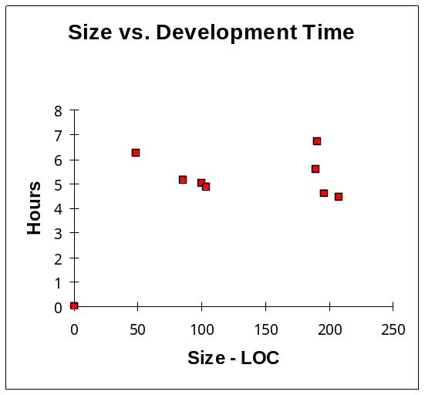
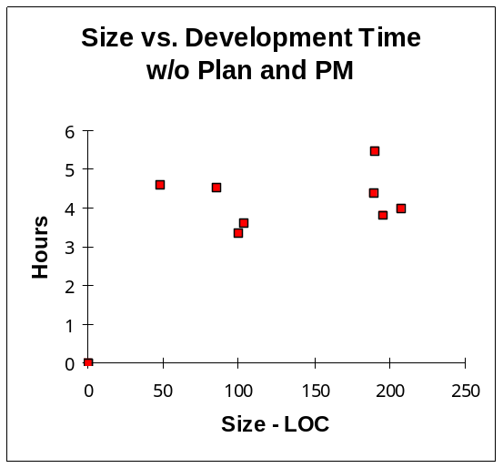
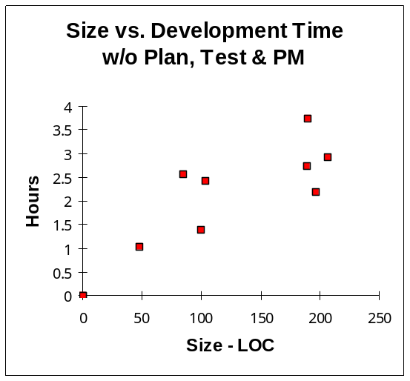
PSP Final Report Process Script

Phase # | Purpose | To guide the analysis and writing of the PSP Final Report
 | Entry Criteria
 | Planning
 | Postmortem
 | Exit Criteria
PSP Final Report Plan Summary

Student |  |  | Date
Instructor

Size Data Effort Estimate

Object |  | Plan Number |  | Actual Number |  | Est Effort per Object |  | Estimated Effort
 |  |  |  |  |  | Total

Effort Data

Phase |  | Plan Time |  | Actual Time
Total

Time Recording Log

Student: |  |  |  |  | Date:
Date | Start |  | Stop | Interruption  Time | Delta  Time | Phase | Comments

